**Tajiri Files NI 43-101 Technical Report for the Yono Gold Property, Guyana**

**VANCOUVER, BRITISH COLUMBIA** - (February 13th, 2025) Tajiri Resources Corp. (the “Company” or “Tajiri”) (TSXV: TAJ) is pleased to announce that it has filed an independent NI 43-101 technical report for the Yono Property, located in Guyana, South America. The report, prepared in accordance with National Instrument 43-101 – *Standards of Disclosure for Mineral Projects* (“NI 43-101”), is available on [SEDAR+](sedarplus.ca) and the Company’s [website](tajirigold.com).

The Yono Property is strategically situated just 170 metres from significant gold resources totalling approximately 5.2 million and 2.7 million ounces (Indicated and Inferred) on the adjacent Oko and Oko West Properties, owned by G2 Goldfields and G Mining Ventures.

The report was prepared by Seymour M. Sears, B.A., B.Sc., PGO of Sears, Barry & Associates Limited in connection with the Company’s proposed acquisition of a 65% working interest in the Yono Property. It provides a comprehensive analysis of the Yono Property, confirming key geological features previously disclosed by the Company.

The full report is available on SEDAR+ at [www.sedarplus.ca](http://www.sedarplus.ca).

Key findings from the report include:

“***The Yono Property is strategically located very close to adjoining, known gold deposits. From a mining perspective, it could be very challenging and restrictive to mine these deposits without having access to the Yono Property***.” [1]

Other noteworthy excerpts from the report include:

***“The Yono Property has excellent potential to host mineralization similar to that on the adjoining properties and similar to other known gold deposits in the region.***

***The Yono Project is a Property of Merit and an extensive multi-phased exploration program is warranted.[2]***

The Company notes several gold targets on the Yono Property have been identified in the report. Of prominence is the potential for strike extensions of the western portions of the higher grade (6.38-9.3g/t Au)[3] Oko Main Zone to extend into the eastern portion of the Yono Property. The report notes:

***“The most recent published drill results by G2 Goldfields (G2 Goldfields Inc. Press Release dated January 7, 2025) appears to show that the Ghanie Zone and OMZ Shear 1 are contiguous and potentially Shear 1 and Shear 3 coalesce between Ghanie and OMZ. In this interpretation Shears 4 & 5 are open to the south of OMZ and substantively untested and potentially project into the Yono Property along its eastern boundary somewhere between its northeastern and southeastern corners.”[4]***

And finally:

**“Favourable sedimentary and volcanic rocks that host gold mineralization on adjacent properties have been mapped in the centre of the Yono Property.”5**

[Figure 1](https://tajirigold.com/wp-content/uploads/2025/02/yono43101image.png) reproduced from Figure 21 of the report illustrates these relations.

**CEO & President Graham Keevil commented** “We’re extremely pleased to have completed this most crucial step in the Yono Property acquisition approval process. Additionally, the independent technical report further serves to confirm our belief that the Yono Property could be highly prospective and a potentially invaluable part of the developments at the two neighbouring gold projects.”

**Qualified Person**

The technical contents of this news release have been reviewed and approved by Dominic O’Sullivan. Mr. O’Sullivan is a geologist, member of the AusIMM and a qualified person, as defined by NI 43-101. However, Mr. O’Sullivan is not independent of the Company by virtue of his position as Executive Chairman.

On Behalf of the Board,

**Tajiri Resources Corp.**

***Graham Keevil,***

President & CEO

***About Tajiri***

*Tajiri Resources Corp. is a junior gold exploration and development Company with exploration assets located in two of the worlds least explored and highly prolific greenstone belts of Burkina Faso, West Africa and Guyana, South America. Lead by a team of industry professionals with a combined 100 plus years’ experience the Company continues to generate shareholder value through exploration.*

**Contact Information:**

Tajiri Resources Corp.  
Graham Keevil  
President, CEO  
778-229-9602  
[graham@tajirigold.com](mailto:graham@tajirigold.com)

[www.tajirigold.com](http://www.tajirigold.com)

**Forward-Looking Statements**

This news release contains “forward-looking information” and “forward-looking statements” (collectively, “forward-looking statements”) within the meaning of the applicable Canadian securities legislation. All statements, other than statements of historical fact, are forward- looking statements and are based on expectations, estimates and projections as at the date of this news release, including without limitation; anticipated results of geophysical surveys or drilling programs, estimated timing, geological interpretations and potential mineral recovery processes. Any statement that involves discussions with respect to predictions, expectations, beliefs, plans, projections, objectives, assumptions, future events or performance (often but not always using phrases such as “expects”, or “does not expect”, “is expected”, “anticipates” or “does not anticipate”, “plans”, “budget”, “scheduled”, “forecasts”, “estimates”, “believes” or “intends” or variations of such words and phrases or stating that certain actions, events or results “may” or “could”, “would”, “might” or “will” be taken to occur or be achieved) are not statements of historical fact and may be forward-looking statements.

*Forward-looking statements contained herein are made as of the date of this press release, and the Company disclaims, other than as required by law, any obligation to update any forward-looking statements whether as a result of new information, results, future events, circumstances, or if management’s estimates or opinions should change, or otherwise. There can be no assurance that forward-looking statements will prove to be accurate, as actual results and future events could differ materially from those anticipated in such statements. Accordingly, the reader is cautioned not to place undue reliance on forward- looking statements.*

Neither the TSXV nor its Regulation Services Provider (as that term is defined in the policies of the TSXV) accepts responsibility for the adequacy and / or accuracy of this release.

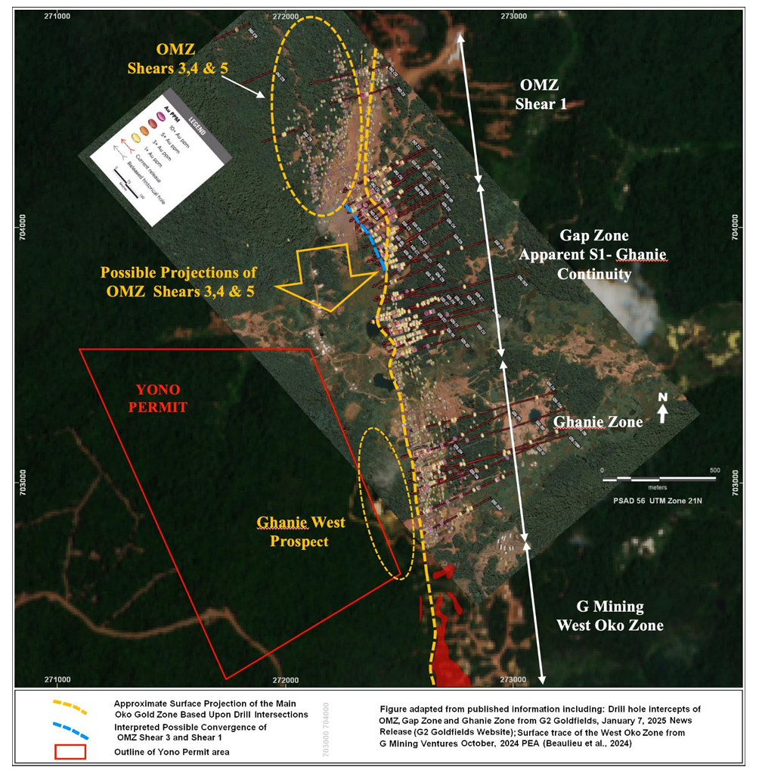

[**Figure 1**](https://tajirigold.com/wp-content/uploads/2025/02/yono43101image.png) Illustrating that Ghanie and West Oko Gold Deposits are contiguous to Oko Main Shear Zone 1 while the projections of the high-grade Oko Main Shear Zones 4, 5 and potentially 3 are presently open to the south and untested and may project into the eastern part of the Yono Property.

1. Page 97- (last paragraph) of the NI 43-101 Technical Report on the Yono Property, Guyana, South America
2. Page 2- (Section 1.6) of the NI 43-101 Technical Report on the Yono Property, Guyana, South America
3. The potential quantity and grade of mineralization disclosed in this news release are conceptual in nature. There has been insufficient exploration to define a mineral resource, and it is uncertain whether further exploration will result in the target being delineated as a mineral resource. The potential quantity and grade disclosed in this news release are based on a combination of factors, including historical exploration data, geological mapping, geophysical surveys, geochemical sampling, structural interpretations, and comparisons to known mineralized zones in the region. These factors indicate the presence of mineralization; however, further exploration, including drilling and resource modelling, is required to determine whether a mineral resource can be defined. Investors are cautioned that the exploration target is not being reported as part of any current mineral resource estimate and should not be relied upon as an indication of future resource potential.
4. 4 Page 52 (last paragraph) of the NI 43-101 Technical Report on the Yono Property, Guyana, South America

   5 Page 8 (last paragraph) of the NI 43-101 Technical Report on the Yono Property, Guyana, South America